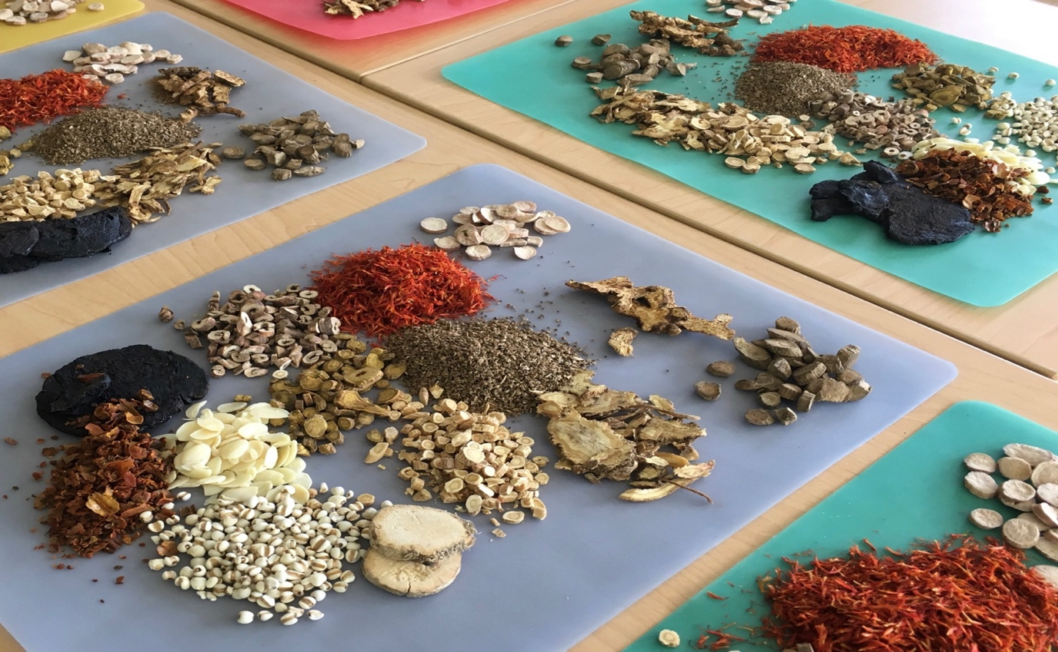

The Chinese Herbal Telemedicine Clinic
Delivering patient centered care safely and effectively
No matter how far the distance between you and your health care providers, technology is now helping to bridge the gap. This approach, called **Telemedicine, will radically expand access to high-quality health care.

In Traditional Chinese Medicine, the key to good health utilizes common sense.
- Eating a balanced diet and getting plenty of rest.
- Exercising regularly.
- Enjoying harmonious and appropriate relationships.
- Avoiding excessive amounts of alcohol or other poisons/toxins.
In situations where disharmony is manifested, the primary goal of Traditional Chinese Medicine is to restore balance using herbal remedies and lifestyle modifications.

**Telemedicine appointments are confidential and HIPPA compliant and herbs are shipped to your home or office safely.

